2022 International Conference on Guidance, Navigation and Control (ICGNC 2022)
http://icgnc.buaa.edu.cn/
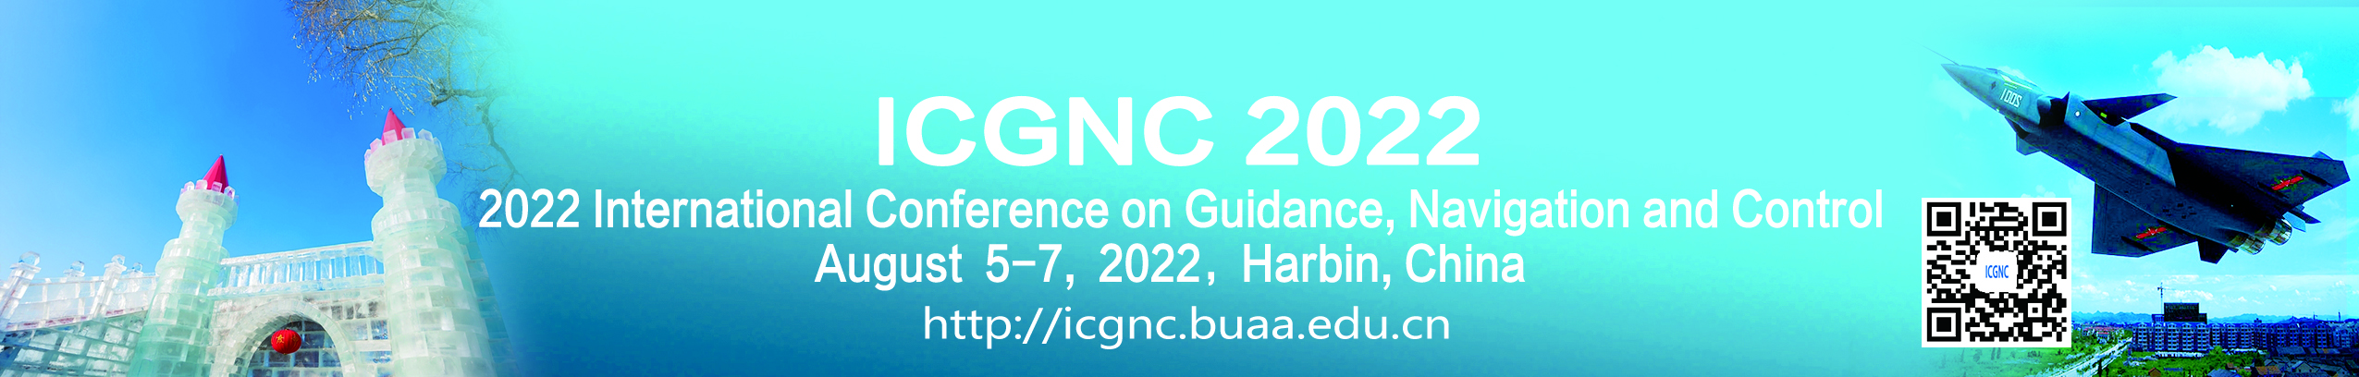
The 2022 International Conference on Guidance, Navigation and Control (ICGNC 2020) will be held in Tianjin on August 5-7, 2022, following the successes of previous nine events. International Conference on Guidance, Navigation and Control (ICGNC) is a biennial event, which is also one of the leading events in Guidance, Navigation and Control(GNC).

ICGNC 2022 is sponsored by Technical Committee on Guidance, Navigation and Control (TCGNC), Chinese Society of Aeronautics and Astronautics(CSAA), and Science and Technology on Aircraft Control Laboratory. It is technically co-sponsored by Technical Committee on Navigation, Guidance and Control(TCNGC), Chinese Association of Automation(CAA), Technical Committee on Unmanned Aerial Systems Autonomous Control(TCUASAC), Chinese Association of Automation (CAA), and Technical Committee on Control Theory(TCCT), Chinese Association of Automation (CAA). ICGNC2022 is organized by Harbin Engineering University.

The conference papers in English presented at the ICGNC 2022 will be published by Springer (indexed by EI-Compendex). Several best English papers of them will be selected for SCI-indexed Journals.

We sincerely welcome our colleagues worldwide to join us for this conference. We look forward to seeing you in Tianjin for this exciting event!

Conference Language: English / Chinese
Official Website: http://icgnc.buaa.edu.cn/

Important Dates:
Paper submission deadline: March 10, 2022
Special session proposals deadline: February 25, 2022
Paper acceptance notification date: April 5, 2022
Final paper submission deadline: April 25, 2020
Early registration: April 25, 2020
Contact Information:
Prof. Renlin Tang, School of Automation Science and Electrical Engineering, Beihang University (BUAA), No.37, Xueyuan Road, Haidian District, Beijing 100083, P. R. China
Tel: +86-10-82317318
Mob: +86-13621186338
E-mail: icgnc_gncc@126.com
http://icgnc.buaa.edu.cn/

